Brodifacoum

Collaborative Study

Full Scale Collaborative Study
for the
Determination of
Brodifacoum AI and Ready to Use Bait (RB) formulations, by
High Performance Liquid Chromatography

Report to CIPAC
by
Syngenta Crop Protection AG
Susanne De Benedictis
Im Breitenloh 5
CH-4333 Münchwilen
Switzerland

May 2014

Content page

1. Participants 3
2. Active Ingredient: General Information 5
3. Samples 6
4. Method 6
4.1 Scope 6
4.2 Principle 6
4.3 Procedure 6
5. Remarks of the Participants 7
6. Evaluation and Discussion 9
6.1 Data Review 9
6.2 Determination of Brodifacoum 9
6.3 Determination of Brodifacoum Cis / Trans Isomer Ratio in Brodifacoum TGAI 16
7. Conclusions 18

Participants

In December 2013, Information Sheet No. 301 was sent out by the CIPAC Secretary inviting members to participate in a collaborative study on the determination of Brodifacoum, by high performance liquid chromatography.
The number of participants was originally limited to 12, but due to the high response rate, finally the first 18 respondents have been accepted.
Due to major difficulties in shipping highly toxic material around the globe only 12 of the 18 respondents received the samples.
By the beginning of May 2014, all 12 participants sent back their results.

Participants are listed in alphabetical order whereas lab numbers in the result tables were assigned, chronologically, based upon receipt of results.

Benke, Lajos | National Food Chain Safety office  Directorate of Plant Protection, Soil Conservation  and Agrienvironment Pesticide Analytical Laboratory  2481 Velence  Hungary
Csiscay František, MVDr. | Department of Environmental Protection and Organic Protection  84429 Bratislava  Slovak Republic
de Aguila, Elisabeth | Laboratorios Control de Calidad de Plaguicidas MAG-OIRSA  Ministerio de Agricultura y Ganadería  San Salvador  El Salvador, C.A.
De Ryckel, Bernard Ing. | Walloon Agricultural Research Center  5030 Gembloux  Belgium
Garvey, Jim Dr. | Pesticide Control Laboratory  Backweston Celbridge  Co. Kildare  Ireland
Haustein, Michael Dr. | CURRENTA  41538 Dormagen  Germany
Jacobsen, Eva | Teknologisk Institut  8000 Aarhus  Denmark
Manso, Luis | Ministerio de Agricultura, Alimentación y Medio Ambiente  Laboratorio Arbitral Agroalimentario  28023 Madrid  Spain

Phillips, Tom | Maryland Department of Agriculture  State Chemist Section  Annapolis MD 21401  United States
Tolle, Sebastian Dr. | BASF SE  67117 Limburgerhof  Germany
Watanabe, Takashi | Agricultural Chemicals Inspection Station  Food and Agricultural Materials Inspection Center  187-0011 Tokyo  Japan
Welte, Ignaz | Syngenta Crop Protection Muenchwilen AG  4333 Muenchwilen  Switzerland

Active Ingredient: General Information

Chemical name: 3-[3-(4'-bromobiphenyl-4-yl)-1,2,3,4-tetrahydro-1-naphthyl]-4-hydroxycoumarin

ISO common name: Brodifacoum

CAS-Nr.: 56073-10-0

Structure:

Molecular mass: 523.4

Empirical formula: C₃₁H₂₃BrO₃

Activity: Rodenticide

Samples

Five test samples, analytical standards and an internal standard were sent to the participants:

- Brodifacoum tech., sample 1
- Brodifacoum tech., sample 2
- Brodifacoum RB 0.005, sample 1
- Brodifacoum RB 0.005, sample 2
- Brodifacoum RB 0.005, sample 3

Due to the highly toxic nature of these samples (esp. pure Brodifacoum in form of technical samples and reference standards) it was decided to limit the amount to the lowest possible one, i.e. to the effective weighing needed. This procedure required the addition of an internal standard for the determination of Brodifacoum technical.
The determination of the formulation anyway requires the use of an internal standard.
Each lab has received pre-weighed vials, one for each weighing and day of Brodifacoum technical and reference standards including an internal standard. In addition also the pre-weighed amount of internal standard used for the analysis of Brodifacoum RB formulation was provided together with 3 samples (not pre-weighed) of Brodifacoum Ready to use Bait (RB) formulation.

Method

Scope
Determination of the active ingredient content of Brodifacoum in technical grade active ingredient and Ready to use Bait formulations.

Principle
Brodifacoum is determined by high performance liquid chromatography, UV detection at 266 nm and internal standardization (for the determination in RB-formulation).

Procedure
Each sample was analyzed using four independent determinations. The samples were analyzed on two different days with duplicate injections of two weighings per sample. Test and reference solutions were prepared fresh on each day. In order to calculate the response factor the mean of the response factor (double injection) before and after the samples were used (bracketing). The sample content was calculated using the mean value of the duplicate injections.

Remarks of the Participants

Several participants provided comments about the method performance and also made a note of any deviations from the method:

Laboratory 1 Kinetex, C18 2.6 µm, 100 x 4.6 mm, flow 1.2 ml/min
no comments

Laboratory 2 Use of an ultrasonic batch instead of a magnetic stirrer (same extraction time)
no comments

Laboratory 3 no comments

Laboratory 4 no comments

Laboratory 5 we had problems with the quantitative transfer of the internal standard on day 1 no problems on day 2 (use of a second cannula for pressure balance in the vial)

Laboratory 6 no comments

Laboratory 7 Chrompack Spherisorb ODS-2, 5 µm, 250 x 4.6 mm, injection volume 10 µl (same gradient used, 1 minute longer equilibration time)
no comments

Laboratory 8 C2 standard used for quantitations due to spillage of C1 during preparation of DAY 1 analysis, masses in C1 changed accordingly in the spreadsheet. There were separate dilutions of C2 to make CA1, A2, B1 and B2 used in the analysis. It is not protocol for the laboratory to use pre-weighed standards and internal standards. For DAY 2 analysis, the responses for the CB standards were inconsistent. Subsequent checks on the injection repeatability were carried out and found to be ok.

Laboratory 9 Zorbax Eclipse XDB C18 5 µm, 250 x 3.0 mm, flow 0.8 ml/min; Gradient has same composition but runs in 12 Min
Time Mobile Phase A Mobile Phase B
0 min 50% 50%
12 min 5% 95%
14 min 5% 95%
15–17 min 50% 50%
No comments

Laboratory 10 Zorbax Eclipse XDB C18 5 µm, 150 x 4.6 mm, flow 1.5 ml/min;
Time Mobile Phase A Mobile Phase B
0 min 50% 50%
21 min 5% 95%
21.1–25 min 50% 50%

For sample extraction an “HEIDOLPH Unimax 2010” orbital platform shaker was used at speed 300 rpm / 90 min

Laboratory 11 Agilent SB-C18, 2.7 µm, 150 x 4.6 mm
Very good method, easy to use. We would recommend that the method be miniaturized so there is less solvent used and the method becomes “Greener”

Laboratory 12 column oven temperature 55°C
Excellent separation of the isomers of both active ingredients and fast, and complete and easy extraction of the active ingredients in the blocks bait. This method is going to be useful in the analysis of quality control in block bait formulation type.

Evaluation and Discussion

Data Review

The data obtained from each laboratory was reviewed to determine if there were any significant chromatography differences, from what was expected, which might affect the analytical results.
Visual examination of the chromatograms and data indicated no significant differences in all cases.
All method deviations, noted by the participants, were deemed not to affect the analytical results significantly.
Laboratory 5 noted an issue with the quantitative transfer of the internal standard for the formulation analysis on Day 1. This needs to be considered as a major impact on the results for all RB formulation batch analysis on Day 1 performed by Laboratory 5. Nevertheless also these data have been included in the statistical evaluation.

Determination of Brodifacoum

The statistical evaluation of the data was accomplished following the “Guidelines for CIPAC Collaborative Study Procedures for Assessment of Performance of Analytical Methods”, according to DIN ISO 5725. Results reported by the laboratories and the statistical evaluation of these are listed in tables 1-3 and displayed in figures 1-5. The results are reported without any exclusion of outliers and/or stragglers.

The statistical evaluation in Table 3 shows that, even without elimination of any outliers or stragglers, the between lab experimental Relative Reproducibility Standard Deviation (% RSD_{R}) is well below the calculated Horwitz value (% RSD_{R (Hor)}) for the Brodifacoum technical samples 1 and 2, as well as the Brodifacoum RB 0.005 formulation samples 1-3.

The data was then examined for outliers and stragglers using Cochran’s test (within-lab variance), followed by Grubb’s test on the lab means (between lab variance). The tests were performed at an alpha level of 0.01 for outlier, and 0.05 for straggler detection. Based on this procedure, the Cochran variance homogeneity test identified Laboratory 5 as an outlier for the RB 0.005 sample 2 data and as straggler for the RB 0.005 sample 1 data. Laboratory 8 was identified as an outlier for the technical sample 2 and as straggler for the technical sample 1.
The Grubb’s test identified Laboratory 9 as an outlier for the technical sample 2. Laboratory 5 was identified as a straggler for RB 0.005 sample 1.
No iterations were required during this outlier/straggler detection process.

Exclusion of the data which were identified as outlier or straggler, was relinquished as the between lab experimental Relative Reproducibility Standard Deviation (% RSD_{R}) is well below the calculated Horwitz value (% RSD_{R (Hor)}) even without exclusion.

Determination of Brodifacoum– no elimination of any outliers / stragglers

All results for the technical samples tabulated in table 1 and 2 are given in g/kg, while all results for the RB 0.005 formulation samples are given in mg/kg.

Table 1 Results
 | Brodifacoum tech. - sample 1 |  | Brodifacoum tech. -sample 2 |  | Brodifacoum RB 0.005 - sample 1 |  | Brodifacoum RB 0.005 - sample 2 |  | Brodifacoum RB 0.005 - sample 3
 | Day1 | Day2 | Day1 | Day2 | Day1 | Day2 | Day1 | Day2 | Day1 | Day2
Laboratory 1 | 982.1 | 979.8 | 978.7 | 978.0 | 45.1 | 44.1 | 45.3 | 44.4 | 44.8 | 44.6
Laboratory 2 | 978.0 | 981.8 | 980.1 | 974.5 | 47.6 | 47.8 | 47.2 | 47.1 | 47.6 | 47.9
Laboratory 3 | 981.1 | 982.2 | 977.9 | 979.3 | 44.9 | 44.0 | 44.6 | 43.6 | 44.7 | 44
Laboratory 4 | 981.7 | 981.8 | 978.7 | 979.7 | 44.7 | 43.8 | 43.2 | 42.9 | 45.3 | 42.1
Laboratory 5 | 980.6 | 981.7 | 978.5 | 977.8 | 36.5** | 43.8** | 36.3* | 43.8* | 39.6 | 43.8
Laboratory 6 | 981.3 | 981.7 | 978.5 | 979.6 | 44.5 | 45.6 | 44.5 | 44.1 | 44.7 | 44.4
Laboratory 7 | 982.5 | 982.3 | 978.8 | 976.3 | 45.4 | 45.8 | 44.8 | 44 | 45.5 | 44.7
Laboratory 8 | 969.1** | 981.9** | 966.2* | 979.2* | 46.9 | 44.6 | 46.7 | 44.6 | 46.4 | 44.6
Laboratory 9 | 986.7 | 987.3 | 986.3 | 986.6 | 44.8 | 44.4 | 45.4 | 46.3 | 45.9 | 46.7
Laboratory 10 | 981.9 | 981.6 | 978.4 | 979.0 | 42.6 | 42.8 | 42.9 | 42.4 | 43.3 | 42.8
Laboratory 11 | 981.6 | 991.8 | 978.2 | 971.7 | 44.2 | 45.2 | 44.2 | 47.3 | 46.7 | 48.9
Laboratory 12 | 982.7 | 981.3 | 979.1 | 978.7 | 48.3 | 42.8 | 45.4 | 42.2 | 47.1 | 41.1

* Cochran outlier
** Cochran straggler

Table 2 Mean values

 | Brodifacoum tech. -  sample 1 | Brodifacoum tech. -  sample 2 | Brodifacoum RB 0.005 - sample 1 | Brodifacoum RB 0.005 - sample 2 | Brodifacoum RB 0.005 - sample 3
Laboratory 1 | 981.0 | 978.4 | 44.6 | 44.9 | 44.7
Laboratory 2 | 979.9 | 977.3 | 47.7 | 47.2 | 47.8
Laboratory 3 | 981.7 | 978.6 | 44.5 | 44.1 | 44.4
Laboratory 4 | 981.8 | 979.2 | 44.3 | 43.1 | 43.7
Laboratory 5 | 981.2 | 978.2 | 40.2⁺⁺ | 40.1 | 41.7
Laboratory 6 | 981.5 | 979.1 | 45.1 | 44.3 | 44.6
Laboratory 7 | 982.4 | 977.6 | 45.6 | 44.4 | 45.1
Laboratory 8 | 975.5 | 972.7 | 45.8 | 45.7 | 45.5
Laboratory 9 | 987.0 | 986.5⁺ | 44.6 | 45.9 | 46.3
Laboratory 10 | 981.8 | 978.7 | 42.7 | 42.7 | 43.1
Laboratory 11 | 986.7 | 975.0 | 44.7 | 45.8 | 47.8
Laboratory 12 | 982.0 | 978.9 | 45.6 | 43.8 | 44.1

⁺ Grubbs outlier
⁺⁺ Grubbs straggler

Table 3 Summary of the statistical evaluation

no elimination of any outliers / stragglers

 | Brodifacoum tech. - sample 1 | Brodifacoum tech. - sample 2 | Brodifacoum RB 0.005 - sample 1 | Brodifacoum RB 0.005 - sample 2 | Brodifacoum RB 0.005 - sample 3
Xm | 981.9 | 978.3 | 44.6 | 44.3 | 44.9
L | 12 | 12 | 12 | 12 | 12
Sr | 3.49 | 3.26 | 1.98 | 1.87 | 1.76
SL | 1.62 | 2.22 | 1.17 | 1.28 | 1.28
SR | 3.85 | 3.94 | 2.30 | 2.27 | 2.18
r | 9.78 | 9.12 | 5.54 | 5.25 | 4.92
R | 10.78 | 11.04 | 6.44 | 6.36 | 6.09
RSDr | 0.36 | 0.33 | 4.44 | 4.23 | 3.92
RSDR | 0.39 | 0.40 | 5.16 | 5.13 | 4.85
RSDR(Hor) | 2.01 | 2.01 | 9.03 | 9.04 | 9.03

Horwitz Limit fulfilled for all test samples

x_{m} = overall sample mean
L = number of laboratories
s_{r} = repeatability standard deviation
RSD_{r} = relative repeatability standard deviation
r = repeatability limit
s_{R} = reproducibility standard deviation
RSD_{R} = relative reproducibility standard deviation
R = reproducibility limit
s_{L} = “pure” between laboratory standard deviation

Fig. 1

Brodifacoum tech. – sample 1

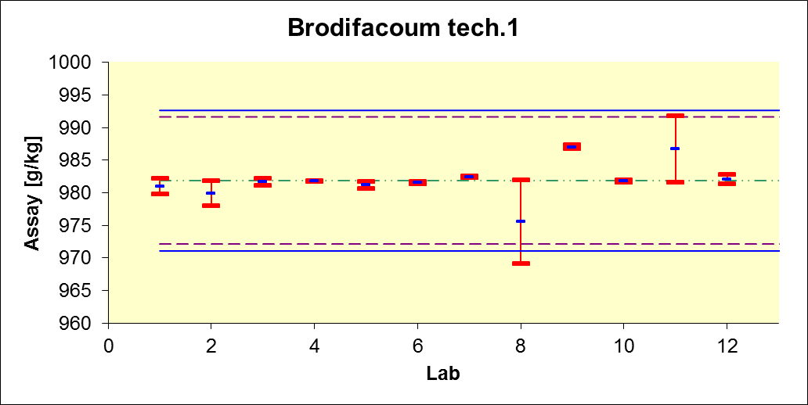
R limits

r limits

Mean

Fig. 2

Brodifacoum tech. – sample 2
R limits

r limits

Mean
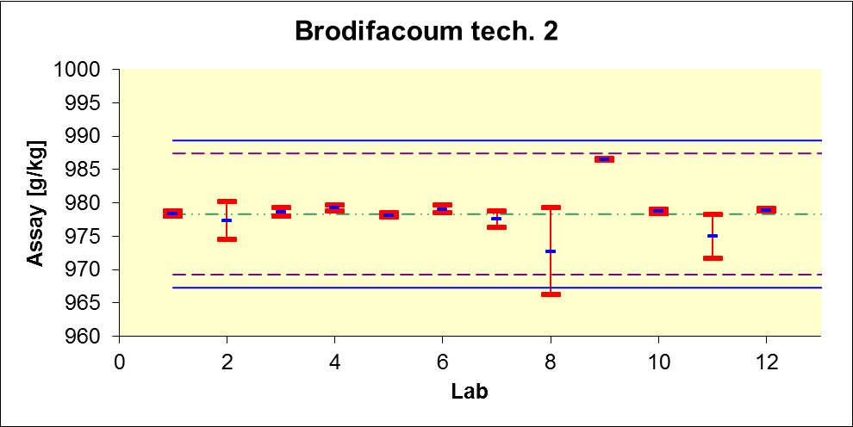

Fig. 3

Brodifacoum RB 0.005 – sample 1

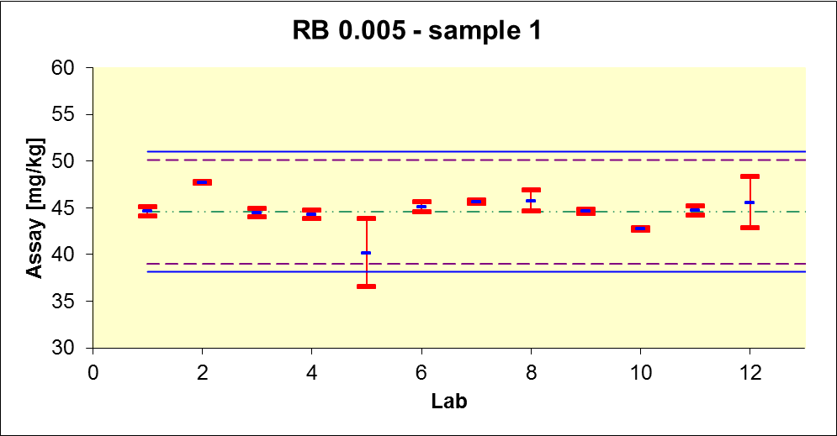
R limits

r limits

Mean

Fig. 4

Brodifacoum RB 0.005 – sample 2

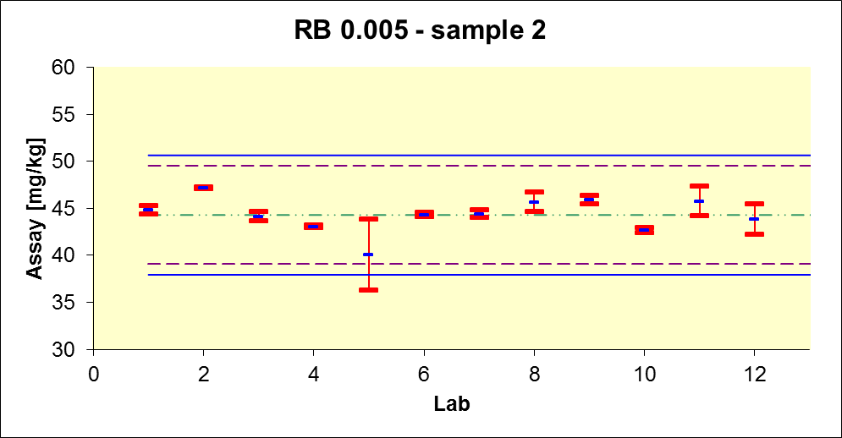
R limits

r limits

Mean

Fig. 5

Brodifacoum RB 0.005 – sample 3

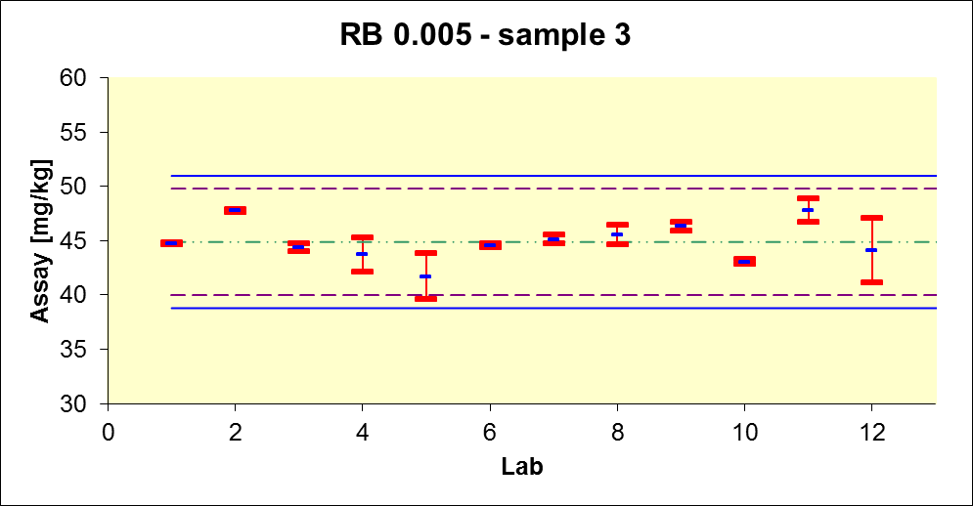
R limits

r limits

Mean

Determination of Brodifacoum Cis / Trans Isomer Ratio in Brodifacoum TGAI

Results reported by the laboratories and the evaluation are listed in tables 4 and 5.
The overall mean compared to the minimum and maximum values obtained showed excellent agreement of the data over all participating laboratories.
Even the use of different column types and different column dimensions showed to have no impact on the determination of the Cis / Trans Isomer Ratio.

Table 4 Results

 | Brodifacoum tech. - sample 1 |  |  |  | Brodifacoum tech. - sample 2
 | Day 1 |  | Day 2 |  | Day 1 |  | Day 2
 | Cis Isomer | Trans Isomer | Cis Isomer | Trans Isomer | Cis Isomer | Trans Isomer | Cis Isomer | Trans Isomer
Laboratory 1 | 56.0 | 44.0 | 56.0 | 44.0 | 55.6 | 44.4 | 56.2 | 43.8
Laboratory 2 | 56.4 | 43.6 | 56.1 | 43.9 | 55.8 | 44.2 | 55.7 | 44.3
Laboratory 3 | 56.1 | 43.9 | 56.1 | 43.9 | 55.6 | 44.4 | 55.7 | 44.3
Laboratory 4 | 56.1 | 43.9 | 56.1 | 43.9 | 55.7 | 44.3 | 55.7 | 44.3
Laboratory 5 | 56.1 | 43.9 | 56.1 | 43.9 | 55.7 | 44.3 | 55.6 | 44.4
Laboratory 6 | 56.1 | 43.9 | 56.1 | 43.9 | 55.7 | 44.3 | 55.6 | 44.4
Laboratory 7 | 56.4 | 43.6 | 56.3 | 43.7 | 55.9 | 44.1 | 55.9 | 44.1
Laboratory 8 | 56.0 | 44.0 | 56.1 | 43.9 | 55.5 | 44.5 | 55.7 | 44.3
Laboratory 9 | 56.0 | 44.0 | 56.3 | 43.7 | 55.7 | 44.3 | 55.8 | 44.2
Laboratory 10 | 56.0 | 44.0 | 56.1 | 43.9 | 55.7 | 44.3 | 55.6 | 44.4
Laboratory 11 | 56.0 | 44.0 | 56.2 | 43.8 | 55.7 | 44.3 | 55.7 | 44.3
Laboratory 12 | 56.1 | 43.9 | 56.1 | 43.9 | 55.7 | 44.3 | 55.6 | 44.4

Table 5 mean values

 | Brodifacoum tech. - sample 1 |  | Brodifacoum tech. - sample 2
 | Cis Isomer | Trans Isomer | Cis Isomer | Trans Isomer
Laboratory 1 | 56.0 | 44.0 | 55.9 | 44.1
Laboratory 2 | 56.2 | 43.8 | 55.8 | 44.2
Laboratory 3 | 56.1 | 43.9 | 55.7 | 44.3
Laboratory 4 | 56.1 | 43.9 | 55.7 | 44.3
Laboratory 5 | 56.1 | 43.9 | 55.7 | 44.3
Laboratory 6 | 56.1 | 43.9 | 55.7 | 44.3
Laboratory 7 | 56.3 | 43.7 | 55.9 | 44.1
Laboratory 8 | 56.1 | 43.9 | 55.6 | 44.4
Laboratory 9 | 56.1 | 43.9 | 55.8 | 44.2
Laboratory 10 | 56.1 | 43.9 | 55.7 | 44.3
Laboratory 11 | 56.1 | 43.9 | 55.7 | 44.3
Laboratory 12 | 56.1 | 43.9 | 55.6 | 44.4
Overall mean | 56.1 | 43.9 | 55.7 | 44.3
Min | 56.0 | 43.7 | 55.6 | 44.1
Max | 56.3 | 44.0 | 55.9 | 44.4

Conclusions

A total of 12 different laboratories have participated in this full scale collaborative study.
Upon review of the chromatographic data all results appear to be valid.

The decision to use an internal standard for the determination of Brodifacoum in technical samples for this collaborative trial was entirely based on safety considerations. This approach allowed shipping the lowest possible amount of toxic material to the participating laboratories.
In cases where sufficiently high amounts of technical material are available for weighing an internal standard shouldn’t be necessary.

Without elimination of any outliers or stragglers the between lab experimental Relative Reproducibility Standard Deviation ( % RSD_{R} ) is well below the calculated acceptable value based on the Horwitz curve calculation (% RSD_{R (Hor)}) for the Brodifacoum technical samples 1 and 2, as well as for the Ready to use Bait RB 0.005 samples 1 to 3 (Table 3).

The evaluation of the Cis / Trans Isomer ratio showed very low variation between the labs.

Therefore we consider this method to be suitable without further changes and recommend accepting it as a provisional CIPAC method for the determination of Brodifacoum in TGAI and RB formulations (Ready to use Bait).

